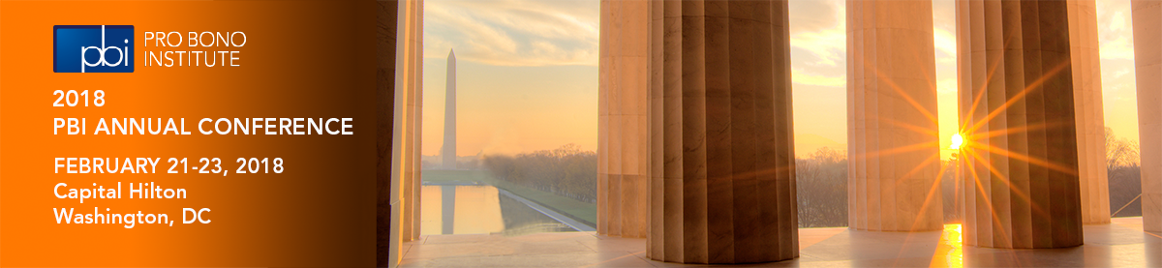
2018 PBI Annual Conference
Request for Ideas

The 2018 PBI Annual Conference will take place on February 21-23 in Washington D.C. We welcome your input. Please share suggestions for session topics, speakers, and any other ideas you may have.

To submit suggestions please complete and return this form to Corporate Pro Bono Project Assistant Virginia Lyon by September 15th.

CONTACT INFORMATION

Name:
Organization:
Email Address:

PROPOSED SESSION DETAILS

Session Title:
Session Description:

Speaker(s):

ADDITIONAL INFORMATION/SUGGESTIONS

*Please attach additional pages if necessary.

Thank you for your leadership and dedication to pro bono.

